**Fiducial Reference Measurements for Ground-Based DOAS Air-Quality Observations**



**ESA Contract No. 4000118181/16/I-EF**



**Questionnaire for MAX-DOAS network assessment in view of joining the FRM4DOAS centralised processing system**

Date: 13/04/2017

Version: 1.0

**Contributing authors:**

F. Hendrick and M. Van Roozendael (BIRA-IASB)

A. Richter (IUP-Bremen)

U. Friess (IUP-Heidelberg)

K. Kreher (BKScientific GmbH)

A. Piters (KNMI)

T. Wagner (MPIC)

J. von Bismarck, A. Dehn, and T. Fehr (ESA)

1. **Introduction**

Fiducial Reference Measurements (FRM) are a suite of independent, fully characterized, and traceable ground measurements that follow the guidelines outlined by the GEO/CEOS Quality Assurance framework for Earth Observation (see http://qa4eo.org). These FRM provide the required confidence in data products, in the form of independent validation results and satellite measurement uncertainty estimation, over the entire end-to-end duration of a satellite mission (for more information, see https://earth.esa.int/web/sppa/activities).

The Fiducial Reference Measurements for Ground-Based DOAS Air-Quality Observations (FRM4DOAS) is a 2-year ESA project which started in July 2016. It aims at further harmonization of MAXDOAS systems and data sets, through the

* specification of best practices for instrument operation
* demonstration of a centralised NRT (near-real-time/6-24h latency) processing system for MAXDOAS instruments operated within the international Network for the Detection of Atmospheric Composition Change (NDACC)
* establishment of links with other UV-Visible instrument networks, e.g. Pandonia

The target species for the first phase of the project are tropospheric and stratospheric NO2 vertical profiles, total O3 columns, and tropospheric HCHO profiles. The aim is to produce homogenous ground-based reference datasets from instruments being operated at long-term monitoring sites (e.g. NDACC) or during field campaigns. Such reference data sets will play a crucial role in the validation of future atmospheric composition satellite missions, in particular the ESA Copernicus Sentinel missions S-5P, S-4, and S-5. More detailed information about the project can be found on the FRM4DOAS website (http://frm4doas.aeronomie.be).

A general overview of the FRM4DOAS service is given in Figure 1. Although the NRT MAX-DOAS centralized processing system will be demonstrated on a limited number of stations from project partners (11 sites in total; see Table 1), it will be designed to allow efficient ingestion and processing of radiance spectra (Level 1 data) from a large number of instruments and sites not part of the initial project. The system will also allow for extension to additional species such as SO2, CHOCHO, HONO and H2O.

Participants joining the FRM4DOAS Service as data providers will benefit from the following advantages:

* Free-of-charge systematic Level 1 (radiance spectra) to Level 2 (vertical columns and profiles) NRT processing service
* Only 6-24h latency between the submission of the spectra and the availability of final products data files
* Continuous quality monitoring for both Level 1 and 2 data with automated feedback to instrument PI in case of anomaly
* Increased data visibility as part of an international network (NDACC)
* Collaboration to international operational validation projects, e.g. in the frame of Copernicus
* Processed level-2 data for scientific use by instrument PIs but also by the overall scientific community

In return of the processing service, instrument PIs will commit to follow the FRM4DOAS guidelines and standards in terms of best practices, data acquisition protocol, and QA/QC for instrument calibration and operation. The protocol for participation to the FRM4DOAS Service will be described in living documents to be made available on the FRM4DOAS website (see http://frm4doas.aeronomie.be/ProjectDir/Deliverables/FRM4DOAS_D4_MAXDOAS_Best_Practices_20170328_preliminary.pdf). To protect the Intellectual Property Rights of the instrument PIs and avoid any misuse of the generated data sets, a strict data policy will be applied.

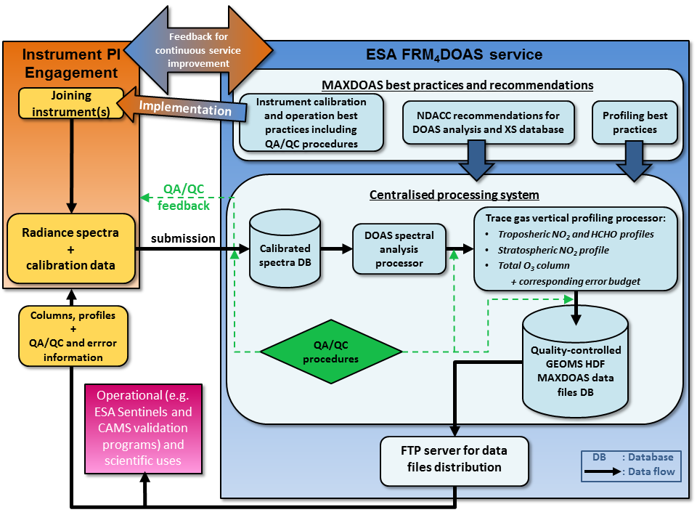

Figure 1: Detailed flow-chart of the FRM4DOAS service.

Table 1: MAXDOAS sites planned for integration in the FRM4DOAS demonstration processing system

|  |  |  |  |  |
| --- | --- | --- | --- | --- |
| Location | Lat (°N) | Long (°E) | Alt (m) a.s.l | Owner |
| Ny-Alesund, Norway | 79 | 12 | 15 | IUPUB |
| Bremen, Germany | 53 | 9 | 50 | IUPUB |
| Cabauw, The Netherlands | 52 | 5 | 0 | KNMI |
| Uccle, Belgium | 51 | 4 | 104 | BIRA |
| Mainz, Germany | 50 | 8 | 50 | MPIC |
| Heidelberg, Germany | 49 | 8 | 115 | UHEID |
| Xianghe, China | 40 | 116 | 178 | BIRA/ IAP-CAS |
| Athens, Greece | 38 | 24 | 300 | IUPUB |
| Bujumbura, Burundi | -3 | 29 | 820 | BIRA |
| Lauder, New-Zealand | -45 | 170 | 370 | NIWA |
| Neumayer | -71 | -8 | 50 | UHEID |

The FRM4DOAS project aims to develop and set up the basis for a sustainable operational system providing Fiducial Reference Measurements that in the long term shall contribute to the regular stream of satellite validation data. Starting with the Sentinel-5 Precursor planned to be launched in August 2017, continued by the low-earth Sentinel-5 and the geostationary Sentinel-4 series in the early 2020s, there is a multi-decadal requirement for air-quality FRMs. In this context the resulting FRM4DOAS data set is a main source to verify the quality of these and other future atmospheric composition satellite programmes. Beyond the on-going initiating two-year project, ESA plans to financially support the operations and developments for FRM4DOAS, as well as a contribution to the operational MAX-DOAS activities, to ensure the long-term availability of a harmonised atmospheric composition data set.

The NDACC UV-VIS Working Group (<http://ndacc-uvvis-wg.aeronomie.be>) is part of the established Network for the Detection of Atmospheric Composition Change, where UV-Visible instruments contribute since more than two decades to the regular monitoring of stratospheric trace gases, in particular O3, NO2, BrO and OClO, total column amounts. NDACC instruments are formally evaluated and quality assessed through participation to regular intercomparison exercises. Protocols and procedures have also been established to ensure network consistency and long-term stability of the generated data records.

FRM4DOAS aims to bring new capabilities to the NDACC by operationally generating the tropospheric data products needed to support the validation of current and future atmospheric composition satellite missions such GOME-2/METOP, AURA/OMI, Sentinel 4, 5 and 5P, TEMPO, GEMS, etc.

The purpose of the present document is to identify the potential candidate instruments for future inclusion in the FRM4DOAS processing system. To this aim, we kindly ask you to fill the questionnaire below indicating your interest for eventual participation.

1. **Questionnaire**

**Personal details:**

Name :………………………………………………………………………

Position :………………………………………………………………………

Institute + address :………………………………………………………………………

:………………………………………………………………………

:………………………………………………………………………

:………………………………………………………………………

:………………………………………………………………………

E-mail :………………………………………………………………………

**Q1/ Are you interested in providing radiance spectra (Level 1 data) from your MAXDOAS instrument(s) to a centralised processing system making use of common community algorithms? If yes, go to Q2; if not, please explain the reason(s) why you are not interested:**

y/n

………………………..

**Q2/ What are the locations (site name + coordinates) of the MAXDOAS instruments from your Institute that could provide Level 1 data to the FRM4DOAS processing system? For each site/instrument, please indicate whether it is already part of NDACC, provide a general classification of the instrument type (e.g. “research grade** **system” , “mini-DOAS”, “EnviMes” etc + pointing/imaging CCD/PDA; outdoor/indoor instrument; manufacturer/custom-built; see example below), and provide instrument specifications according to the Table below:**

Site 1: site_name, country (lat, long); NDACC-affiliated site ? ; instrument type

Site 2: site_name, country (lat, long); NDACC-affiliated site ? ; instrument type

Site 3: site_name, country (lat, long); NDACC-affiliated site ? ; instrument type

Site 4: site_name, country (lat, long); NDACC-affiliated site ? ; instrument type

……

*Example:*

*Site 1: Bremen, Germany (53°N, 9°E), NDACC-Yes, research grade, pointing, CCD, indoor, custom-built*

Instrument specifications (mark relevant specification with a cross):

|  |  |  |  |  |
| --- | --- | --- | --- | --- |
|  | **Site 1** | **Site 2** | **Site 3** | **Site 4** |
| UV spectral range (300-400nm)* | *x (310-390)* |  |  |  |
| Visible spectral range (400-550nm)* |  |  |  |  |
| Depolarizing fiber(s) |  |  |  |  |
| Fiber light mixing |  |  |  |  |
| Detector(s) cooling |  |  |  |  |
| Instrument thermal stabilization |  |  |  |  |
| Elevation scan capability |  |  |  |  |
| Azimuthal scan capability |  |  |  |  |
| Direct-sun pointing capability |  |  |  |  |

*Please also mention the spectral range in nm (see example in *italic*).

Comments (optional):

………….

**Q3/ What are your usual procedures for instrument characterization/calibration ?**

Instrument characterization and calibration (mark relevant specification with a cross):

|  |  |  |  |  |
| --- | --- | --- | --- | --- |
|  | **Site 1** | **Site 2** | **Site 3** | **Site 4** |
| Slit function (ISRF) |  |  |  |  |
| Wavelength registration |  |  |  |  |
| Dark signal |  |  |  |  |
| Spectral stray-light |  |  |  |  |
| Detector non-linearity |  |  |  |  |
| Detector interpixel variability |  |  |  |  |
| Field of view |  |  |  |  |
| Elevation angle |  |  |  |  |
| Radiometric calibration |  |  |  |  |

Comments (optional):

………….

**Q4/ How do you operate your instrument(s) ?**

Instrument operation (mark relevant specification with a cross):

|  |  |  |  |  |
| --- | --- | --- | --- | --- |
|  | **Site 1** | **Site 2** | **Site 3** | **Site 4** |
| Automatic operation |  |  |  |  |
| Automatic calibration |  |  |  |  |
| Automatic QA/QC of instrument parameters |  |  |  |  |
| Documentation (e.g. data acquisition protocol, calibration report, etc) |  |  |  |  |

Comments (optional):

………….

**Q5/ What are the procedure in place for data transfer ?**

Station->institute data transfer (mark relevant specification with a cross):

|  |  |  |  |  |
| --- | --- | --- | --- | --- |
|  | **Site 1** | **Site 2** | **Site 3** | **Site 4** |
| Manual |  |  |  |  |
| Automatic with a latency >24h |  |  |  |  |
| Automatic with a latency <24h |  |  |  |  |

Comments (optional):

………….

**Q6/ What is the current latency for spectral data accessibility ?**

Calibrated radiance spectra ready for DOAS processing (mark relevant specification with a cross):

|  |  |  |  |  |
| --- | --- | --- | --- | --- |
|  | **Site 1** | **Site 2** | **Site 3** | **Site 4** |
| Manual |  |  |  |  |
| Automatic with a latency >24h |  |  |  |  |
| Automatic with a latency <24h |  |  |  |  |
| Final QA/QC check on calibrated radiance spectra implemented |  |  |  |  |

Comments (optional):

………….

**Q7/ Please list below your relevant publications (i.e. where your instrument(s) and data are described and/or used):**

……………………

**Q8/ Please list below your relevant past and current international research projects (i.e. projects in relation to your MAXDOAS measurements):**

……………………

**Q9/ In case you would join the FRM4DOAS centralized processing system, would you be willing to be involved in future community efforts for improving standards ?**

y/n

**Q10/ If not yet the case, would you be willing to affiliate to NDACC ? If not, could you explain why ?**

y/n

……………………

**Q11/ General comments and constraints**

Comments/remarks/questions are welcome, e.g. about your financial and manpower constraints/efforts to reach FRM4DOAS standards.

…………..

Please return to:

Dr François Hendrick, BIRA-IASB (francois.hendrick@aeronomie.be)