NDACC MAX-DOAS Service

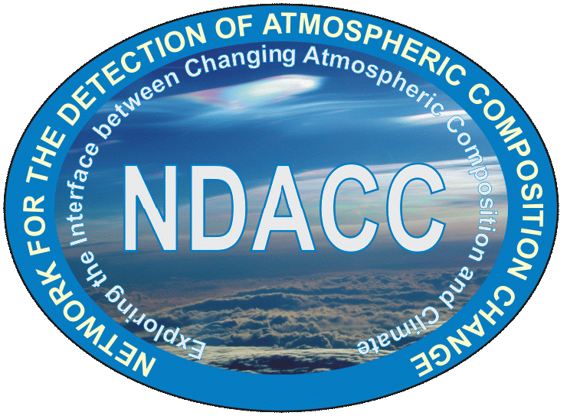

Questionnaire for using the NDACC MAX-DOAS Central Processing Facility

Date: 02/04/2020
Version: 2.0
Contributing authors:
F. Hendrick, M. Friedrich, C. Fayt, M. Van Roozendael (BIRA-IASB)
A. Richter, T. Bösch (IUP-Bremen)
U. Friess, L. Tirpitz (IUP-Heidelberg)
A. Piters (KNMI)
T. Wagner, S. Beirle (MPIC)
K. Kreher (BK Scientific)
A. Bais (AUTH)
C Prados-Roman (INTA)
A. Dehn, S. Casadio, P. Castracane (ESA)

- Introduction
The NDACC (Network for the Detection of Atmospheric Composition Change) MAX-DOAS Service, launched on 30 April 2020, provides a NRT (24h latency) central processing facility for data from MAX-DOAS spectrometers. Including also specification of best practices for instrument operation, the aim of this service, developed under the ESA project FRM₄DOAS (see http://frm4doas.aeronomie.be), is to produce homogenous and quality-controlled ground-based MAX-DOAS datasets at long-term monitoring sites or during field campaigns. The current target species are lower tropospheric aerosol extinction and trace gas (NO₂, HCHO) vertical profiles, total O₃ columns, and stratospheric NO₂ vertical profiles. Such data sets, produced according to quality standards of Fiducial Reference Measurements (FRMs) will feed operational satellite validation servers in support of current and future atmospheric composition satellite missions, in particular the ESA Copernicus Sentinel missions S-5P, S-4, and S-5.
The purpose of this document is to present the key aspects of the NDACC MAX-DOAS Service and to identify, through a dedicated questionnaire, the candidate instruments for future inclusion into the Service.
- NDACC MAX-DOAS Central Processing Facility description
A general overview of the NDACC MAX-DOAS Service is presented in Figure 1. The Central Processing Facility uses the following retrieval algorithms:
- QDOAS spectral fitting software (Fayt et al., 2011)
- Parameterisation-based MAPA (Beirle et al., 2019) and Optimal-Estimation-based MMF (Friedrich et al., 2019) algorithms for lower tropospheric profiles and vertical columns of aerosols, NO₂ and HCHO (see also Friess et al., 2019)
- Standard AMF-based NDACC approach for the total O₃ column retrieval (Hendrick et al., 2011)
- Optimal-Estimation-based profiling tool for stratospheric NO₂ vertical profiles (Hendrick et al., 2004)
and works as follows: Upon successful registration, level-1 files (spectrally calibrated radiance spectra) are uploaded by instrument PIs on a dedicated incoming FTP server. A standardised netCDF format (see https://frm4doas.aeronomie.be/index.php/frm4doas-guidelines) is required for those level-1 files, offering the possibility to include key data (e.g. reference spectrum and slit function) as well as ancillary data that can be used by the retrieval algorithms, e.g. pressure and temperature profiles and/or aerosol data.
Once being ingested, level-1 data files undergo subsequent processing and corresponding QA/QC for the data products listed above to produce final level-2 products. Those are delivered in (1) an internal netCDF file format that contains the complete and fully traceable set of retrieval variables and ancillary data information, and (2) in the standard GEOMS HDF4 file format (see https://avdc.gsfc.nasa.gov/index.php?site=1876901039). The GEOMS HDF4 files are automatically transferred to the NDACC Rapid Delivery repository with mirroring on the EVDC database, while the access of the full netCDF master output files is currently restricted to instrument PIs. Various diagnostic tools allow to detect anomalies in the processing chain and to generate reports (status on processed files, statistics, list of anomalies, etc.). Upon eventual detection of anomalies, e-mail alerts are sent to concerned instrument PIs.
It should be noted that in addition to the NRT processing, off-line and/or reprocessing retrievals can also be performed. The following three different processing chains will therefore work in parallel:
- NRT: processing in near-real-time, with a target time lag of maximum one day after data acquisition and corresponding GEOMS data files stored in the NDACC/RD repository.
- OFF-LINE: consolidated processing applied to same data as NRT processing, but with optimised algorithms and ancillary information and produced within a maximum delay of 3 months. Data files will be stored in the NDACC/RD repository in replacement of the corresponding NRT GEOMS data files.
- REPROCESSING: processing of historical time-series of observations, performed on demand (from instrument PI) or after major upgrade of NRT/OFF-LINE algorithms. Upon PIs authorization and for instruments formally affiliated to NDACC, such reprocessed data sets are catalogued on the NDACC Consolidated repository on a yearly basis.
So far, the NRT NDACC MAX-DOAS Central Processing Facility is in operation for a limited number of stations (14 in total; see Table 1). However, it has been designed for the efficient ingestion and processing of radiance spectra from a larger number of instruments and sites. In subsequent phases, the system will be extended to allow for processing of additional data products. Possible candidates are e.g. SO₂, CHOCHO, BrO, HONO, H₂O, etc.
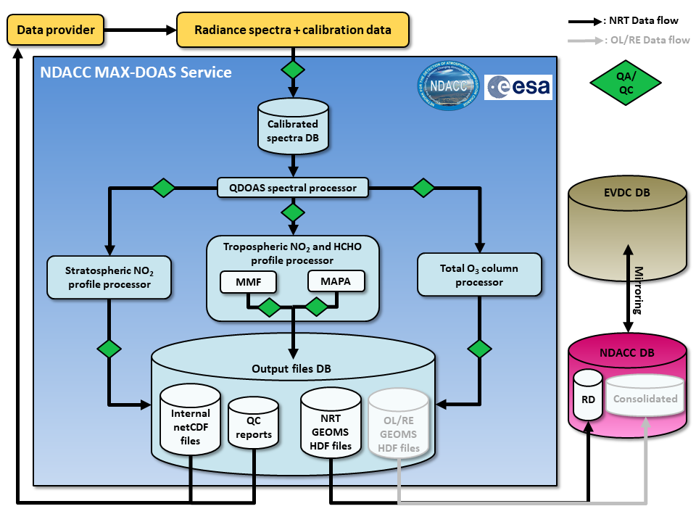
Figure 1: Detailed flow-chart of the NDACC MAX-DOAS Central Processing Facility (NRT: near-real-time; OL: off-line; RE: reprocessing).

Table 1: MAX-DOAS sites currently included in the NDACC MAX-DOAS Central Processing Service
Location | Lat (°N) | Long (°E) | Owner
Ny-Alesund, Norway | 79 | 12 | IUPUB
Haresua, Norway | 60 | 11 | BIRA-IASB
Bremen, Germany | 53 | 9 | IUPUB
De Bilt, The Netherlands | 52 | 5 | KNMI
Uccle, Belgium | 50 | 4 | BIRA
Mainz, Germany | 50 | 8 | MPIC
Heidelberg, Germany | 49 | 9 | UHEID
Thessaloniki, Greece | 41 | 23 | AUTH
Xianghe, China | 37 | 116 | BIRA-IASB / IAP-CAS
Athens, Greece | 38 | 24 | IUPUB / NOA
Izana, Spain | 28 | -16 | INTA
La Reunion Maïdo | -21 | 55 | BIRA-IASB
Lauder, New-Zealand | -45 | 170 | NIWA
Neumayer | -71 | -8 | UHEID

- Added value for PIs joining the NDACC MAX-DOAS Central Processing Facility
Instrument PIs joining the NDACC MAX-DOAS Service will benefit from the following advantages:
- Free-of-charge systematic level-1 (radiance spectra) to level-2 (vertical columns and profiles) NRT (24h latency) processing service
- Continuous data quality monitoring with automated feedback to instrument PIs in case of anomalies
- Increased data visibility as part of an international network (NDACC)
- Possibility to contribute in international operational validation projects, e.g. in the frame of the EU Copernicus program (see https://atmosphere.copernicus.eu/)
- Processed level-2 data made available for scientific use by instrument PIs but also by the overall scientific community
In order to be eligible for the processing service, instrument PIs must provide evidences attesting of the quality of their measurements and commit to follow the FRM₄DOAS guidelines and standards in terms of best practices, data acquisition protocol, and QA/QC for instrument calibration and operation. Those are described in living documents available at https://frm4doas.aeronomie.be/index.php/frm4doas-guidelines. Instrument PIs have also to share their resulting GEOMS files at least on the NDACC RD repository.
To protect the Intellectual Property Rights of the instrument PIs and avoid any misuse of the generated data sets, a strict data policy based on the Creative Common license system (see https://creativecommons.org/licenses/) is applied. The traceability of the datasets is ensured via systematic DOI assignment.
- References
Beirle, S., Dörner, S., Donner, S., Remmers, J., Wang, Y., and Wagner, T.: The Mainz profile algorithm (MAPA), Atmos. Meas. Tech., 12, 1785–1806, https://doi.org/10.5194/amt-12-1785-2019, 2019
Fayt, C., De Smedt, I., Letocart, V., Merlaud, A., Pinardi, G., and Van Roozendael, M.: QDOAS Software user manual, http: //uv-vis.aeronomie.be/software/QDOAS/index.php, 2011.
Friedrich, M. M., Rivera, C., Stremme, W., Ojeda, Z., Arellano, J., Bezanilla, A., García-Reynoso, J. A., and Grutter, M.: NO₂ vertical profiles and column densities from MAX-DOAS measurements in Mexico City, Atmos. Meas. Tech., 12, 2545–2565, https://doi.org/10.5194/amt-12-2545-2019, 2019.
Frieß, U., Beirle, S., Alvarado Bonilla, L., Bösch, T., Friedrich, M. M., Hendrick, F., Piters, A., Richter, A., van Roozendael, M., Rozanov, V. V., Spinei, E., Tirpitz, J.-L., Vlemmix, T., Wagner, T., and Wang, Y.: Intercomparison of MAX-DOAS vertical profile retrieval algorithms: studies using synthetic data, Atmos. Meas. Tech., 12, 2155–2181, https://doi.org/10.5194/amt-12-2155-2019, 2019.
Hendrick, F., B. Barret, M. Van Roozendael, H. Boesch, A. Butz, M. De Mazière, F. Goutail, C. Hermans, J.-C. Lambert, K. Pfeilsticker, and J.-P. Pommereau, Retrieval of nitrogen dioxide stratospheric profiles from ground-based zenith-sky UV-visible observations: Validation of the technique through correlative comparisons, Atmos. Chem. Phys., 4, 2091-2106, 2004.
Hendrick, F., J.-P. Pommereau, F. Goutail, R. D. Evans, D. Ionov, A. Pazmino, E. Kyrö, G. Held, P. Eriksen, V. Dorokhov, M. Gil, and M. Van Roozendael, NDACC/SAOZ UV-visible total ozone measurements: Improved retrieval and comparison with correlative ground-based and satellite observations, Atm. Chem. Phys., 11, 5975-5995, 2011.

- Questionnaire
We kindly ask you to fill in the questionnaire below indicating your interest in participating in the NDACC MAX-DOAS Service and its Central Processing Facility. For those who responded to the FRM₄DOAS questionnaire released in May 2017, we also ask you to fill in the questionnaire with updated information about your MAX-DOAS instrument(s).
Personal details:
PI name :………………………………………………………………………
Position :………………………………………………………………………
Institute + address :………………………………………………………………………
:………………………………………………………………………
:………………………………………………………………………
:………………………………………………………………………
:………………………………………………………………………
E-mail :………………………………………………………………………

Q1/ Are you interested in providing radiance spectra (level-1 data) from your MAX-DOAS instrument(s) to the NDACC MAX-DOAS Central Processing Facility taking advantage of common community algorithms? If yes, go to Q2; if not, please explain the reason(s) why you are not interested:
y/n
………………………..

Q2/ What are the locations (site name + coordinates) of the MAX-DOAS instruments from your institute that could provide level-1 data to the NDACC MAX-DOAS Central Processing Facility? For each site/instrument, please indicate whether it is already part of NDACC, provide a general classification of the instrument type (e.g. “research grade system” , “mini-DOAS”, “EnviMes”, “Airyx”, “Pandora”, etc + pointing/imaging CCD/PDA; outdoor/indoor instrument; manufacturer/custom-built; see example below), and provide instrument specifications according to the Table below:
Site 1: site_name, country (lat, long); NDACC-affiliated site ? ; instrument type
Site 2: site_name, country (lat, long); NDACC-affiliated site ? ; instrument type
Site 3: site_name, country (lat, long); NDACC-affiliated site ? ; instrument type
Site 4: site_name, country (lat, long); NDACC-affiliated site ? ; instrument type
……
Example:
Site 1: Bremen, Germany (53°N, 9°E), NDACC-Yes, research grade, pointing, CCD, indoor, custom-built
Instrument specifications (mark relevant specification with a cross):
 | Site 1 | Site 2 | Site 3 | Site 4
UV spectral range (300-400nm)* | x (310-390)
Visible spectral range (400-550nm)*
Depolarizing fiber(s)
Fiber light mixing
Detector(s) cooling
Instrument thermal stabilization
Elevation scan capability
Azimuthal scan capability
Direct-sun pointing capability
*Please also mention the spectral range in nm (see example in italic).
Comments (optional):
………….

Q3/ Which of the following parameters or procedures are part of your instrument characterization/calibration?
(mark relevant specifications with a cross):
 | Site 1 | Site 2 | Site 3 | Site 4
Slit function (ISRF)
Wavelength registration
Dark signal
Spectral stray-light
Detector non-linearity
Detector interpixel variability
Field of view
Elevation angle
Radiometric calibration

Comments (optional):
………….

Q4/ How do you operate your instrument(s)?
Instrument operation (mark relevant specification(s) with a cross):
 | Site 1 | Site 2 | Site 3 | Site 4
Automatic operation
Automatic calibration
Automatic QA/QC of instrument parameters
Documentation (e.g. data acquisition protocol, calibration report, etc)

Comments (optional):
………….

Q5/ What are the procedures in place for data transfer?
Station->institute data transfer (mark relevant specification with a cross):
 | Site 1 | Site 2 | Site 3 | Site 4
Manual with a latency >24h
Manual with a latency <24h
Automatic with a latency >24h
Automatic with a latency <24h

Comments (optional):
………….

Q6/ What is the current latency for spectral data accessibility?
Calibrated radiance spectra ready for DOAS processing (mark relevant specification with a cross):
 | Site 1 | Site 2 | Site 3 | Site 4
Manual with a latency >24h
Manual with a latency <24h
Automatic with a latency >24h
Automatic with a latency <24h
Final QA/QC check on calibrated radiance spectra implemented

Comments (optional):
………….

Q7/ Please list below your relevant publications (i.e. in which your instrument(s) and data are described and/or used):
……………………

Q8/ If relevant, please list below your past and current international research projects in relation to your MAX-DOAS measurements and your participations to past MAX-DOAS intercomparison campaigns (e.g. CINDI-1 and -2):
……………………

Q9/ Are your MAX-DOAS data currently delivered to operational services, like e.g. the EU CAMS (see https://atmosphere.copernicus.eu/data)?
……………………

Q10/ In case you would join the NDACC MAX-DOAS Central Processing Facility, would you be willing to be involved in future community efforts for improving standards?
y/n

Q11/ If not yet the case, would you be willing to affiliate to NDACC? If not, could you please explain why?
y/n
……………………

Q12/ General comments and constraints
Comments/remarks/questions are welcome, e.g. about your financial and manpower constraints/efforts to reach NDACC MAX-DOAS Service standards.
…………..

Q13/ NDACC MAX-DOAS Service presentation
The present document gives a short overview of the NDACC MAX-DOAS Service (see Sect. 1-4). In which form(s) would you like to see a detailed presentation of the Service?
Tick your preference(s) among the following options:
O Physical meeting (stand-alone workshop or combined to another meeting)
O Teleconference with presentations and interactive discussions (webinar)
O Written documents made available via the web
O Others: ………..

Please return to:
Dr François Hendrick, BIRA-IASB (francois.hendrick@aeronomie.be)

