**Fiducial Reference Measurements for Ground-Based DOAS Air-Quality Observations**

**FRM4DOAS**

**ESA Contract No. 4000118181/16/I-EF**



**Deliverable D4:**

**MAXDOAS Calibration and Operations Best Practices**

Date: 10/01/2018

Version: 1.0

**Contributing authors:**

Andreas Richter (IUP-Bremen)

Enno Peters (IUP-Bremen)

Thomas Wagner (MPIC)

Yang Wang (MPIC)

Karin Kreher (BKScientific GmbH)

Udo Frieß (UHeid)

Francois Hendrick (BIRA-IASB)

Michel Van Roozendael (BIRA-IASB)

Alexis Merlaud (BIRA-IASB)

Alkis Bais (Aristotle University of Thessaloniki)

Ankie Piters (KNMI)

Alexander Cede (Luftblick)

Contents

1 Introduction 5

2 Instrument Characterisation 5

2.1 Instrument set-up 5

2.1.1 Telescope + spectrometer integrated or separated 6

2.1.2 Imaging or pointing 6

2.1.3 Use of quartz fibre bundles 7

2.1.4 Use of mirrors / lenses / prisms 7

2.1.5 Use of fibre mixers 8

2.1.6 Use of straylight filters 8

2.1.7 Temperature stabilisation of the spectrometer 8

2.1.8 Temperature stabilisation of the detector 8

2.2 Supporting measurements 9

2.2.1 Video camera 9

2.2.2 Inclinometer 9

2.2.3 Meteorological observations 9

2.2.4 GPS / Time synchronisation 9

2.3 Instrument Characterisation 10

2.3.1 Spectral properties 10

2.3.2 Pointing properties 11

3 Instrument Calibration 12

3.1 Radiometric calibration 12

3.2 Spectral calibration 13

3.3 FOV and pointing 13

3.3.1 Light source in the lab 13

3.3.2 Light source in the field 14

3.3.3 Illuminated stripe 15

3.3.4 Horizon observations 16

3.4 Spectrometer straylight 17

3.5 Polarisation sensitivity 17

3.6 Dark signal 17

3.7 Spectral / instrumental noise 18

3.8 Detector linearity 18

3.9 Detector pixel-to-pixel variability 19

3.10 Temperature dependence 20

4 Instrument Operation 20

4.1 Operation parameters 20

4.1.1 Which viewing directions 20

4.1.2 Which frequency of zenith-sky observations 21

4.1.3 Which integration times per viewing direction 21

4.1.4 Which strategy for exposure times 21

4.1.5 Which data format 22

4.2 Automatic Characterisation Measurements 22

4.2.1 Dark signal 22

4.2.2 Wavelength 22

4.2.3 Slit function 22

4.2.4 Pointing accuracy 23

4.2.5 FOV 23

4.2.6 Throughput 23

4.3 Automatic QA 24

4.3.1 Intensity checks 24

4.3.2 Slit function 24

4.3.3 Wavelength stability 24

4.3.4 Quick look DOAS retrievals 24

5 References 24

# Introduction

This document is a collection of guidelines and recommendations for best practice approaches to calibration and operation of MAX-DOAS instruments. It is based on an earlier short document developed in the framework of the European Union funded QA4ECV project (<http://www.qa4ecv.eu/>) and was extended and iterated as part of the ESA funded Fiducial Reference Measurements for Ground-Based DOAS Air-Quality Observation (FRM4DOAS) project (<http://frm4doas.aeronomie.be/>). FRM4DOAS is a 2-year ESA project which started in July 2016. It aims at further harmonization of MAX-DOAS systems and data sets, through the

* specification of best practices for instrument operation
* demonstration of a centralised NRT (near-real-time/6-24h latency) processing system for MAXDOAS instruments operated within the international Network for the Detection of Atmospheric Composition Change (NDACC)
* establishment of links with other UV-Visible instrument networks, e.g. Pandonia

While the project itself is limited to tropospheric and stratospheric NO2 vertical profiles, total O3 columns, and tropospheric HCHO profiles from a small number of stations, the aim is to collect and create the necessary information, guidelines and infrastructure which can be the basis for a network including many more MAX-DOAS instruments and covering all MAX-DOAS products.

This document aims at collecting information and guidelines useful for the operation of ground-based MAX-DOAS instruments, in particular for, but not limited to applications in satellite validation. It is not a set of fixed rules and for individual stations, other approaches might be more appropriate. The document does also not contain the level of technical detail needed to implement all the procedures without prior knowledge but can serve as a starting point.

It is expected that this remains a living document with corrections, extensions and other changes implemented by the MAX-DOAS community in the coming years.

# Instrument Characterisation

In spite of their simplicity, MAX-DOAS instruments come in many different forms, ranging from compact commercial devices to big and complex research type instruments. In the following, an overview will be given on parameters characterising the different types of MAX-DOAS instruments.

## Instrument set-up

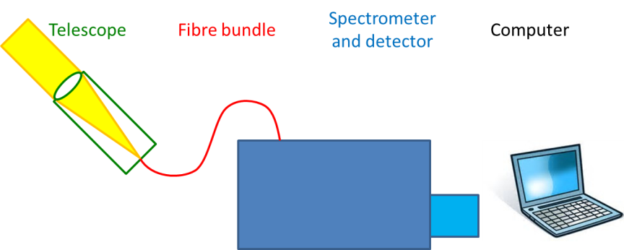

Figure 1: Schematic of a MAX-DOAS instrument

### Telescope + spectrometer integrated or separated

DOAS instruments come basically in two versions:

**Compact:** All components are integrated into one box containing telescope, spectrometer, detector and often computer. This type of instruments usually only needs a power supply and network connection, either via Ethernet or WLAN.

**Separated:** There are two separate units, one containing the telescope and calibration units, the other one consisting of spectrometer, detector and computer. A fibre bundle conducts the light from the telescope to the spectrometer.

The larger and more expensive instruments which usually follow the concept of separation of spectrometer and telescope and are assembled individually by the respective research group are often referred to as ‘scientific instruments’ (see e.g. Carlson et al., 2010; Clémer et al., 2010; Coburn et al., 2011; Wittrock et al., 2004).

Since optical imaging is generally not an issue for a scanning instrument, it should be noted that most DOAS instruments use only a simple collimating lens at a distance of its focal length from the entrance of the quartz fibre and not a telescope in the traditional sense.

The advantages of compact instruments are their simple and versatile use and usually lower price. They are ideal for operation in the field, from cars or in remote regions.

The advantages of a separated instrument are the availability of more space that allows for better spectrometer systems larger in size, the option to put the spectrometer inside a building which enables better temperature control and easy access and in practice less susceptibility to damage of the instrument from harsh weather conditions. In addition smaller tracker systems can be used. For long-term observations high mechanical and thermal stability is required, usually better fulfilled by the separated systems than by the compact systems. A disadvantage of these systems is that the fibre optics may undergo transmission variations with different fibre bending, which would affect retrievals where radiometric stability is needed.

### Imaging or pointing

The defining characteristic of a MAX-DOAS instrument is its ability to measure light scattered in the atmosphere at different elevation angles. There are basically two methods to achieve this:

**Pointing:** With this kind of set-up, the instrument measures light from one viewing angle and direction which is then sequentially changed through all elevation (and azimuth) angles of interest. This set-up is equivalent to the whisk broom approach in satellite observations.

**Imaging:** With an imaging instrument, all viewing directions are measured at the same time by using an imaging telescope or several individually pointing telescopes connected to the same spectrometer. The spectrometer needs to have imaging abilities and the detector needs to be two-dimensional. In such a set-up, the position along the entrance slit is conserved all the way to the spectrum on the detector, allowing separation of several spectra coupled into the spectrometer at different points on the entrance slit. This set-up corresponds to the push broom approach in satellite instruments.

In some instruments, both concepts are combined, for example by using an imaging spectrometer for variation of the elevation angle and a pointing mechanism to scan through several azimuth angles.

The main advantages of a pointing instrument are that it produces measurements with high signal to noise, can be operated at optimum signal levels for each viewing direction and features a constant instrument function regardless of viewing angle.

The main advantages of an imaging instrument are its ability to produce truly simultaneous measurements in several directions and the absence of moving parts in the telescope.

### Use of quartz fibre bundles

Most MAX-DOAS instruments use quartz fibre bundles to connect telescope and spectrometer. This set-up has several advantages:

1. As fibre bundles have low light losses, they can be quite long (many meters), resulting in flexible set-up options. They are therefore essential for instruments with separated telescopes.
2. If the individual fibres within a bundle have a small enough diameter, a fibre bundle can be configured to have a circular aperture at the telescope side and a rectangular shape at the spectrometer slit. This reduces light losses at the slit side of the fibre and minimises the field-of-view of the instrument for the same throughput at the other side, since the later depends on the fibre bundle total diameter.
3. Fibre bundles can also be configured to feed the input of one telescope into several spectrometers covering different wavelength ranges or, in turn, to feed light from different telescopes into one imaging spectrometer.
4. If long enough, quartz fibres are depolarising, minimizing effects from the polarisation dependency of most grating spectrometers in combination with the polarised nature of Rayleigh scattered light.
5. If long enough, quartz fibres cause mode mixing leading to a more homogenous illumination of the spectrometer. Mode mixing can be enhanced by using additional treatment of the fibres, e.g. by increasing the bending angles of the fibres.

Alternatively, telescopes can also be connected to the spectrometer via mirrors but this is done less frequently for MAX-DOAS instruments.

### Use of mirrors / lenses / prisms

In the telescope, lenses or collimating mirrors are used to limit the field of view of the instrument. In the case of pointing instruments, the pointing can be realised either by moving the full telescope or by using a rotating mirror or prism in the telescope to change the pointing direction.

In all cases, choice of material needs to be appropriate for UV or NIR uses depending on the anticipated application. For lenses, the chromatic aberration can become a limiting factor for the quality of the field of view in case of large spectral coverage of the instrument. Use of mirrors for pointing is problematic as they introduce polarisation dependencies and are prone to degradation. For this reason, prisms are the preferred option but care needs to be taken that the glue used for prism mounting does not limit total reflection.

### Use of fibre mixers

If a spectrometer slit is illuminated inhomogeneously, the resulting spectrum will have a different slit function and spectral resolution will be less uniform than for a measurement taken with a homogeneous slit illumination. Therefore some instruments use additional fibre optics between telescope and fibre bundle consisting of one or several thick fibres which are just long enough to create a homogeneous light beam (Coburn et al., 2011). This has been proven to improve the signal to noise in applications with inhomogeneous illumination (for example under light conditions with broken clouds).

### Use of straylight filters

Depending on the wavelength region of interest, instrumental straylight can be a concern in MAX-DOAS instruments as sun light has a large contribution in the visible and NIR part of the spectrum. It is therefore good practice to use wavelength low-pass filters to reduce visible and NIR intensities when performing measurements in the UV or blue part of the spectrum. Depending on instrument set-up, these filters are usually positioned either in the telescope in front of the fibre entrance or at the other end of the fibre bundle in front or just behind the entrance slit of the spectrometer.

Problems with filters can occur due to reflections on the surfaces, fringing from interference and throughput loss due to contamination or degradation, in particular for but not limited to hygroscopic filters.

### Temperature stabilisation of the spectrometer

Most spectrometers are sensitive to temperature variations as mechanical changes result in shifts of the spectrum on the detector and a degradation of the instrumental line shape. How large these effects are depends on focal length and construction of the spectrometer. Mechanical stress can be minimised by stabilising the temperature of the spectrometer by putting it into thermal insulation and equipping it with temperature control, electrical heaters and sometimes also coolers. Depending on the temperature sensitivity of the instrument, a temperature stability of better than 0.1 K may be needed while for other systems, stabilisation within a few Kelvins might be sufficient.

Problems with temperature stabilisation can occur in case of overheating if no cooling is foreseen (or at low temperature if there is no heater) and if temperature oscillations are created by non-ideal temperature control settings. If the temperature control uses only heaters (coolers), the temperature needs to be set sufficiently higher (lower) than surrounding temperature (typically > 10K temperature difference).

### Temperature stabilisation of the detector

Most current MAX-DOAS instruments are equipped with Charge Coupled Devices (CCD) detectors. While the dark signal of such detectors is small, it can further be reduced by cooling the detector. As both, the dark signal and electronic offset of CCDs, depend on temperature, it is useful to stabilise the temperature of the CCD and associated electronic parts to 1K or preferably better accuracy even if it is not cooled. How important temperature stabilisation is and which accuracy is needed depends on the system as instruments have variable temperature sensitivity.

In most scientific instruments, CCDs with integrated temperature control are used. For some miniaturized DOAS instruments, this is not the case and external temperature control can be applied to improve measurement stability. For some compact spectrometers, spectrometer and detector are stabilised in temperature using a single cooling or heating device. If cooling is used, condensation needs to be excluded, e.g. by using a desiccant or by sealing the spectrometer and filling with dry nitrogen, in order to prevent damage to the instrument.

## Supporting measurements

### Video camera

Many instruments take visible images in parallel to the MAX-DOAS observations, mainly for documentation of weather conditions and telescope pointing. If such cameras are calibrated and linear, they can provide quantitative information on clouds, aerosol loading and the instrumental field of view (FOV) (Sihler et al., 2017).

### Inclinometer

Some instruments have built-in inclinometers to monitor (and sometimes also control) the pointing of the telescope. In particular on moving platforms this can be of great use, but also for a simple set-up in the field and for monitoring of long-term performance, such measurements are of interest.

### Meteorological observations

For interpretation of MAX-DOAS measurements, standard meteorological measurements often prove useful. Even if data from meteorological models is available, on-site temperature, wind speed and direction, and surface pressure can be helpful for the data analysis.

In addition to standard meteorological data, sun photometers as well as ceilometers or Lidars located in close proximity to the MAX-DOAS instrument are very valuable resources by providing information on boundary layer height, aerosol optical depth and ideally also aerosol vertical information. Such data can be used to improve air mass factor calculations and profile inversions.

### GPS / Time synchronisation

As knowledge of the solar zenith angle (SZA) is crucial for the computation of air mass factors, in particular for stratospheric applications, accurate time has to be saved with the observations. The exact time is usually provided by a GPS sensor or – in case of separated instruments situated indoors – via network time synchronisation.

On moving platforms, knowledge of the location of measurement is needed which again can be provided by a GPS system. Depending on the speed of movement and measurement, high accuracy GPS systems might be needed. In addition to the position information, the heading, pitch and roll angles of the platform might be needed to properly set-up or, at least, document the orientation of measurements not pointing into the zenith. This information can come from the temporal evolution of the GPS position or from dedicated gyroscopic instruments.

## Instrument Characterisation

### Spectral properties

#### General properties

The most important parameters for characterising the spectral properties of a MAX-DOAS instrument are its spectral range, the spectral resolution, the spectral sampling and the stability of the spectral recording.

The spectral range needs to be large enough to cover the spectral window of interest, and it is usually advisable to have a slightly wider range than actually needed to avoid having to use the edge of the detector. The required spectral resolution depends on species and is usually between 0.2 and 1.0 nm. In general, better spectral resolution improves the information content of the measurements but it also reduces the overall throughput and thus the signal to noise ratio. The optimum choice therefore depends on instrument and species. Spectral sampling needs to be large enough to allow good interpolation of the spectra (Nyquist theorem) and values > 4 are recommended (Roscoe et al., 1996). Spectral stability is key to good DOAS fits and one should aim at having stability better than at least 1/10th of a detector pixel by temperature stabilising the spectrometer (see section 2.1.7).

#### Slit function

The slit function or instrument transfer function describes the response of the instrument to a monochromatic input. As result of finite slit width, spectrometer resolving power and aberrations, and detector pixel size, even a single wavelength input will result in a broadened and blurred line on the detector. As the solar spectrum is highly structured by Fraunhofer lines, accurate knowledge of the instrument function is advantageous for passive DOAS retrievals to correct for filling-in of Fraunhofer lines by inelastic scattering (Ring effect) (Grainger and Ring, 1962). The instrument function is essential to convolute the absorption cross-sections of atmospheric gases.

Depending on the instrument type, the slit function can be wavelength dependent and for imaging instruments, it also depends on the vertical position on the detector as result of smile and keystone. This results in a viewing angle dependence of the slit function which needs to be taken into account. In many instruments it also depends on the temperature of the spectrometer and may change over time. Therefore, slit function characterisation is a task that needs to be repeated throughout time in order to identify and characterize changes in the instrument. This will be discussed in more detail in section 3.3.

#### Straylight rejection

As already mentioned in section 2.1.6, instrumental straylight can be a concern in MAX-DOAS measurements. The susceptibility of spectrometers to straylight depends on design details such as focal length, size, number of reflective surfaces and materials used in the instrument. Also, contamination of mirrors and gratings leads to increasing straylight over time. Therefore, characterisation of straylight is of interest for MAX-DOAS instruments and will be discussed in section 3.4.

#### FOV

The size of the field of view (FOV) determines the ability to use the information contained in measurements taken at low elevation angles. This is for two reasons: First, a large field of view will include surface reflection at low elevation angles which has proven to have a negative impact on the retrieval. Second, the box air mass factors change rapidly for low elevation angles, and integration over a large FOV reduces the information content of the measurements. Typically for MAX-DOAS observations at low elevation angles, the FOV should be of about 1° full angle or smaller.

In a simple lens telescope, the FOV is determined by the size of the fibre bundle entrance and the focal length of the lens. If the fibre is not in the focal point of the lens, the FOV is increased. This can be the case for parts of the spectrum if a large spectral range is measured and the lens or telescope has chromatic aberration, leading to changes of FOV with wavelength. If shading is used at the telescope, for example by adding a tube and apertures to the setup, this can also limit the FOV depending on geometry.

### Pointing properties

The general pointing properties of a MAX-DOAS instrument can be described by 1) the range of elevation and azimuth angles that can be set, 2) how fast a given position can be reached, 3) how accurate the pointing is and 4) what the size of the field of view is.

Many MAX-DOAS instruments only vary the elevation angle while being oriented in a fixed azimuthal direction. Such instruments are called 1d (i.e. one angle can be changed). If the azimuthal direction can also be changed, the instrument is referred to as being 2d. While some instruments have no limitations with respect to choice of azimuth and elevation when pointing upwards, mounting as well as cables might pose practical limits. Some instruments have the ability to also point downwards which can be interesting if measuring from elevated locations.

For tropospheric profile observations, most information is obtained from the lowest elevation angles between about 0° and 15°, which means this is the important range. Tropospheric columns can be retrieved well from observations between 15° and 30°, and for stratospheric measurements as well as for the background measurements used in tropospheric retrievals, zenith-sky pointing observations are needed.

Which azimuth directions to choose, depends very much on the local conditions and for 2d instruments, different azimuth directions are used to capture horizontal variability or to increase aerosol information content. If horizontal variability is not an issue, one might want to choose an observation direction away from the sun, for example to the North in the Northern Hemisphere, to reduce the risk of direct sun illumination and to minimize the effect of aerosol scattering on the measurements.

Pointing accuracy is most important with respect to the elevation angle and when pointing close to the horizon. This is especially important when measuring species having large concentration near the surface (e.g. NO2 or HONO). Here, already 0.1° can make a large difference in particular if the instrument has a small FOV, so high accuracy is needed to avoid significant errors in the retrievals. At larger elevation angles, the requirements are less stringent and at 30°, even a few degrees of mispointing are not critical. The same is true for the azimuth direction unless pointing at targets or the sun is to be performed. For those instruments having 2d capability, exact levelling is needed to ensure that a selected elevation angle is constant over the full range of azimuthal directions. Accurate levelling should be checked frequently as structural movements of buildings or the telescope set-up may occur in the course of a year.

Speed of operation is an issue if rapid measurements are needed, for example to monitor temporal changes or if good azimuthal and elevation coverage is aimed at using short integration times. For measurements in a single azimuth direction, speed is usually not an issue.

#### Direct sun capability

Direct sun observations can add additional information to MAX-DOAS measurements, both on aerosol properties and total trace gas columns. In principle, many MAX-DOAS instruments can point at the sun, but in order to achieve sufficiently accurate pointing, active corrections by scanning the sun’s disk in azimuth and zenith or by using a quadrant detector or a camera with image processing software are often used.

As the signal during direct sun observations is much larger than during scattered light measurements, filters or a diffusor need to be used for direct sun observations in order to avoid detector saturation. Use of a diffusor also reduces inhomogeneous slit illumination which is a problem for direct sun observations. Special care needs to be taken to have the same illumination of the instrument FOV during scattered light and direct sun operation if spectra from both observation modes are to be fitted against each other as otherwise the slit functions for the two observation modes might not agree.

A positive ‘side-effect’ for instruments measuring both sky and direct sun is that a high pointing accuracy in all directions can be achieved, since the direct sun observations allow to frequently check the pointing on a moving target (the sun).

# Instrument Calibration

While one of the advantages of DOAS observations is a large degree of cancellation of instrumental effects and effective self-calibration, there still are some instrumental parameters which need to be known with good accuracy and therefore need calibration before operation and at regular intervals during operations.

## Radiometric calibration

In contrast to other optical instruments, such as sun-photometers, MAX-DOAS instruments are usually not radiometrically calibrated. This is not needed for two reasons: First, analysis is performed relative to a background measurement taken with the same instrument, thereby cancelling all multiplicative effects as long as the instrument was stable between the two measurements. Second, the DOAS method relies on differential structures in the optical depth, and as long as the instrument throughput does not change in a wavelength dependent way between the two measurements, it will not affect the DOAS results.

Having radiometrically calibrated instruments can in principle increase the information content of the spectra with respect to cloud and aerosol retrievals and also helps in tracing uncertainties in a metrological sense. Pandora instruments measuring aerosol optical depths from direct sun observations (see http://pandonia.net/) are an example of an MAX-DOAS instrument type requiring absolute radiometric calibration. It is likely that future instruments will aim at producing radiometrically calibrated spectra (e.g. Wagner et al., 2015).

## Spectral calibration

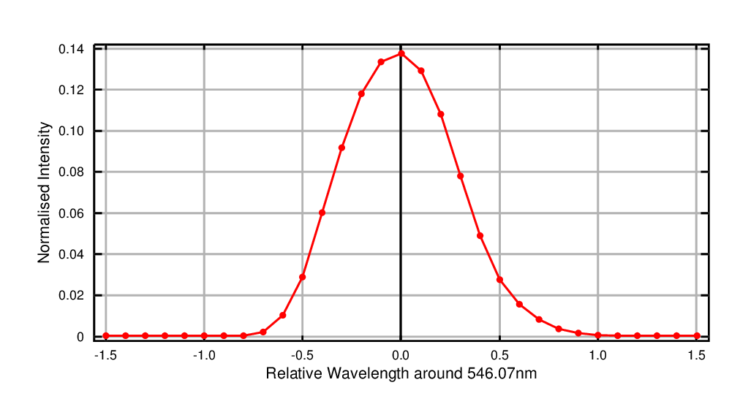

Figure 2: Example of a slit function measured with an HgCd line lamp.

Spectral calibration is the assignment of wavelengths to the measurements from individual pixels on the detector and the determination of the instrument’s slit function. This can be done by using highly structured light sources with known wavelength dependency. In practice, these are either atomic emission line lamps, lasers or the solar spectrum itself, measured with a Fourier Transform Spectrometer at high spectral resolution and accuracy. The wavelength calibration is then performed by assigning pixel-wavelength pairs for a number of emission lines and fitting a polynomial through all these pairs. If the Fraunhofer spectrum is used, it first is convoluted with the instrument slit function and then the wavelength axis of the measurement is determined using a correlation or non-linear fitting technique (Caspar and Chance, 1997).

Spectral calibration is often repeated on a regular basis as described in section 4.2.2.

## FOV and pointing

For the FOV of the instrument, different parameters are of interest: The opening angle of the telescope and its wavelength dependence but also the accuracy and repeatability of the pointing in elevation and azimuthal direction. In addition, the shape of the FOV in elevation and azimuthal direction is also of interest. Different methods can be used to characterize the FOV as discussed in the following sections.

### Light source in the lab

In the lab, the FOV of a MAX-DOAS instrument can be determined by using a point source at a large distance from the instrument and displacing it horizontally and vertically or by varying the elevation and/or azimuth angle of the telescope in a small angular range around the light source. The FOV can then be computed from the width of the resulting intensity curve as a function of elevation angle (telescope response function). A similar characterisation can be performed in the azimuthal direrction. The elevation angle can be calibrated simultaneously when the light source is placed exactly at the same height as the telescope entrance (e.g., using a laser level) and at a known angle. The centre of the telescope response function then corresponds to the position of the horizon.

### Light source in the field

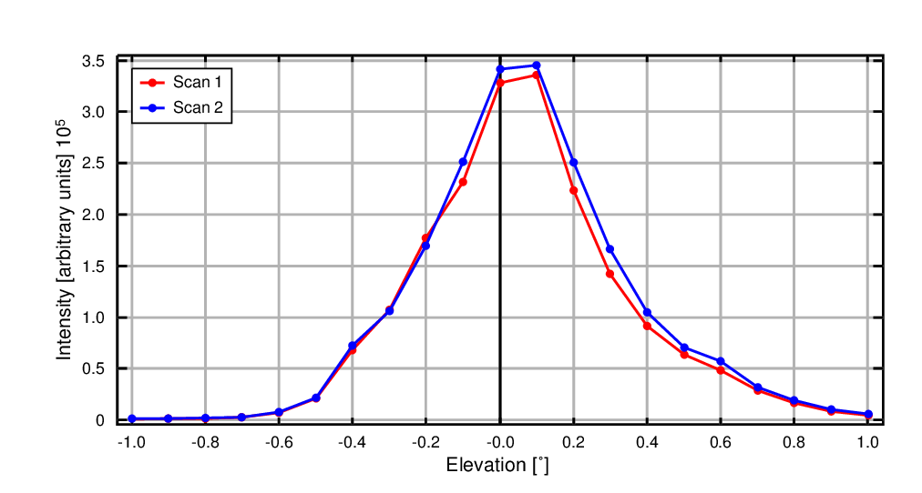

Figure 3: Example of two elevation scans over a distant light source performed during CINDI-2

If a strong light source such as a Xenon discharge car lamp with a modified telescope is available, it can be used at night to measure the FOV of the instrument under field conditions. The measurement is performed at night by positioning the lamp at a distance of a few hundred meters or more from the instrument and pointing it towards the MAX-DOAS instrument. The instrument then performs scans in elevation and azimuth to first find the light source and then to measure the variation in intensity as a function of angular separation from the centre of the light source. In this way, both the elevation and azimuthal FOV can be characterized. The further away the lamp is positioned from the instrument, the better the approximation of a point source is, but at the same time the intensity reduces and an increasingly finer angular movement of the telescope is needed.

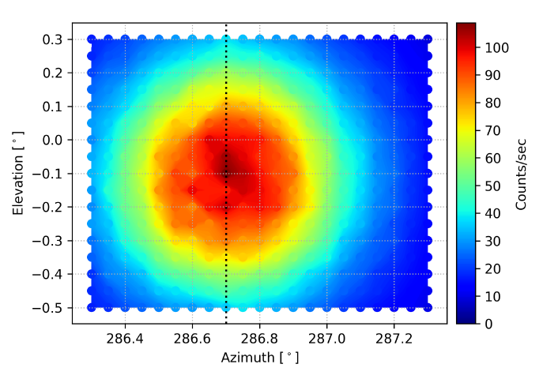

Figure 4: Example of 2-D characterization of the FOV using a distant light source during CINDI-2

If the distance between lamp and instrument is large enough, the measurements can also be used to determine the pointing of the instrument. This can be calculated geometrically by using the exact positions of instrument and lamp and their altitude above sea level, for example from accurate GPS readings or digital maps. It should be pointed out that this works best in very flat areas and that the positions should be known within a meter (for a distance between the lamp and instrument of about 1 km).

For the choice of lamp it is essential to use a lamp having a large UV output (such as a Xenon discharge lamp) to achieve a sufficient signal to noise ratio in the UV. Also narrow spectral band emissions such as in a xenon lamp provide easy to observe signals, at least with instruments covering the respective wavelengths.

Instruments with direct sun capability can also ‘scan the sun’ to obtain the FOV. This is typically done in both azimuth and zenith angle direction and gives very good results on clear sky days. The obtained ‘sun scans’ provide the instrument’s FOV convoluted by a rectangular function of the width of the solar beam. Since this width is well known the true FOV can be obtained by deconvolution. Note however that the instrument FOV may differ in direct-sun and MAX-DOAS mode due to the different entrance optics used. Therefore the FOV must be characterised in both geometries.

### Illuminated stripe

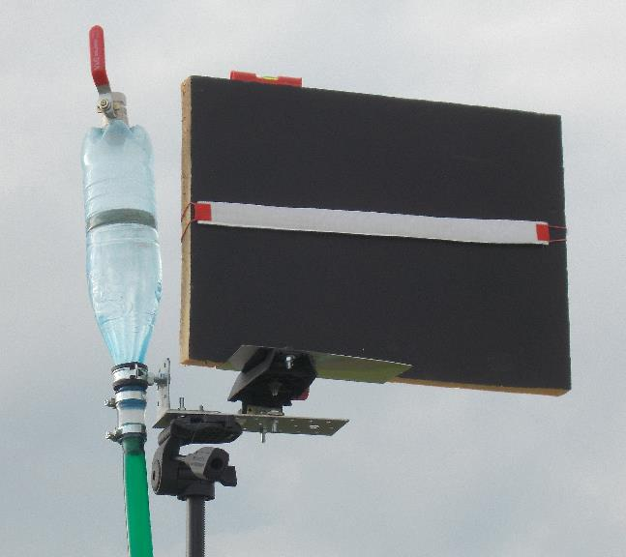 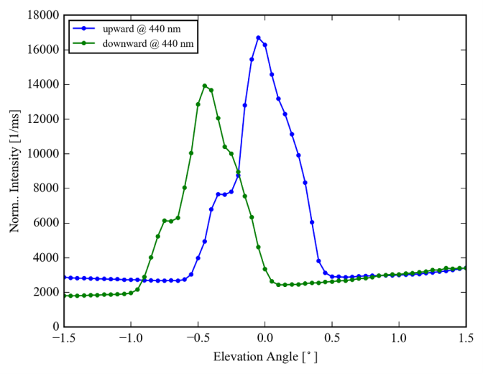

Figure 5: Left: Black plate with a white horizontal stripe as used for the elevation calibration during the CINDI-2 campaign. At the left side of the plate the water level used for the vertical adjustment with the telescope of the instrument is seen. Right: Measured radiance at 440 nm as function of the elevation angle. A clear maximum is found at the position of the white stripe. Note that the location of the maximum is different for upward and downward movement of the telescope motor indicating a problem caused by backlash of the motor.

Lamp measurements are restricted to night time. During daytime, elevation calibration measurements can be performed using targets with sharp contrasts, e.g. a black plate with a horizontal white stripe. The instrument scans across the white stripe and the recorded intensity is displayed as function of the elevation angle. The maximum intensity indicates the true direction of the white stripe. For the adjustment of the height of the white stripe with respect to the height of the telescope, either a laser level (might be not well visible during day) or a water level can be used. Like for the lamp measurements, the distance between the target and the instrument should be not too close, otherwise the true FOV will be substantially overestimated by the derived width of the intensity distribution. It is recommended that the distance should be > 5m, and the vertical extension of the white stripe should be < 2cm.

### Horizon observations

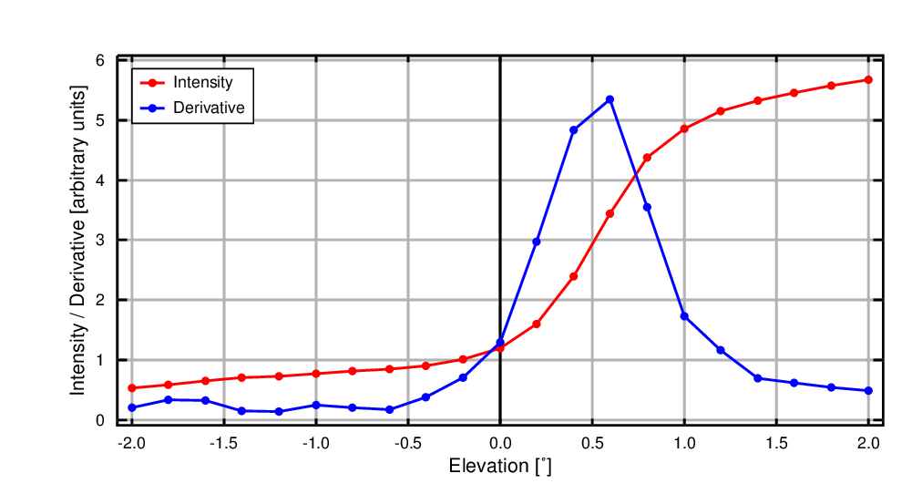

Figure 5: Example of the intensity measured in a horizon scan during CINDI-2 (red line)  
 and the derivative of the intensity (blue line). The maximum at of the derivative at 0.5° elevations   
indicates a misalignment of the telescope.

Usually the horizon is much darker than the atmosphere above. Thus elevation scans with small step sizes (smaller than the FOV, e.g. 0.25°) can be used to determine the elevation angle of the horizon. The measured radiance can be displayed as a function of the elevation angle, and usually a substantial increase is found in the range of elevation angles, where the FOV changes from looking at the surface to looking into the atmosphere. Viewing conditions and illumination should not change during such a horizon scan. One convenient method for the determination of the centre of the FOV is to calculate the derivative of the radiance as function of the elevation angle. The maximum of the derivative indicates the centre of the FOV. Although this method is easy to set up and convenient for automated monitoring of the pointing stability, it should be noted that the calibration using the horizon method is complicated by several aspects:

1. usually the horizon is not exactly located at an elevation angle of 0°. The exact angle of the horizon has to be determined, e.g. from elevation maps and the distance between the instrument and the ‘effective horizon’ (e.g. a mountain ridge). It is important to take into account the exact height of the instrument. Also buildings and trees might have to be considered.
2. care has to be taken that the ‘horizon’ is not too far away. Especially in the presence of high aerosol loads the atmospheric visibility can be low. Thus the geometric horizon may not provide high enough contrast, or may even not be visible at all in the spectral range of the measurements (note that the atmospheric visibility decreases towards short wavelengths). If possible, nearby ‘artificial horizons’ should be used, e.g. the top of buildings or trees.
3. during CINDI-2 it was found that horizon scans yielded slightly different results at different wavelengths. Also the results from the horizon scans were slightly but systematically different from those using the light source in the field. The reason for these differences is so far unknown.

Even if, because of the reasons listed above, it is difficult to determine the exact elevation angle of the horizon, horizon scans can be very useful to check the temporal stability of the horizontal adjustment of the instrument. Horizon scans might e.g. be carried out on a daily basis, if possible (and relevant) at different azimuths.

## Spectrometer straylight

Spectrometer straylight can be an issue for measurements particularly in the UV as it decreases apparent absorptions of atmospheric trace gases. Spectral straylight (photons having the wrong wavelength) is present in all instruments; in imaging instruments there is in addition spatial straylight (photons from the wrong viewing direction). Accurate characterisation of straylight is best performed with a powerful monochromatic light source (tunable laser) operated at different wavelengths (see e.g. Zong et al., 2006). Alternatively, for a more qualitative analysis, optical cut-off filters can be applied which are opaque for wavelengths below a certain threshold in combination with a broadband or monochromatic light source.

In some instruments, straylight can be estimated from the signal observed in regions which should not be illuminated. Examples are instruments covering wavelengths below 300 nm where no sun light is expected due to absorption in the ozone layer. The signal measured at these wavelengths can then be used as a rough estimate of a spectrally uniform straylight. In a similar way spatial straylight can be estimated in imaging instruments using spatially separated stripes of illumination on the CCD.

Detailed characterisation of straylight as done for satellite instruments is complex, expensive and time consuming and therefore usually not performed for MAX-DOAS instruments. Effects of straylight can however be identified and compensated for to some degree in the retrieval by using an additive polynomial of low order (sometimes called offset correction or straylight correction). However, in DOAS analyses usually a measured spectrum is analysed against a Fraunhofer reference spectrum, which is typically affected by a similar straylight level, often the fitted additional offset is found to be small, while the actual straylight level of the individual spectra might be much larger.

## Polarisation sensitivity

The efficiency of both gratings and mirrors is polarisation dependent, and therefore most spectrometers used in DOAS instruments have pronounced polarisation dependency. As atmospheric light is polarised by Rayleigh and also aerosol scattering depending on the relative position of sun and viewing direction, this creates problems in the data analysis. Therefore, most instruments employ fibre optics which are depolarising. Alternatively, the instrument can be operated in a way that the orientation of the spectrometer slit to the solar azimuth is kept constant.

Characterisation of the polarisation sensitivity of the instrument can be done by using an unpolarised broadband light source and placing a polariser in front of the telescope or quartz fibre. i.e. in front of the depolarising part of the system. Measurements taken at different polariser orientations can then be compared and should show no systematic spectral features. If measurements cover UV wavelengths, a UV polariser has to be employed. It must be noted that many light sources, especially filament lamps, are not unpolarised. Therefore they cannot be used by directly illuminating the polarizer for this calibration. Instead their output must go through a depolarizing element first, e.g. an integrating sphere, a diffuser plate or another fibre.

## Dark signal

The dark signal is composed of two components – an electronic offset which is artificially added to the signal independent of exposure time and a second term which increases with exposure time. Both terms depend on temperature and can therefore change during operations. Two different approaches can be used to characterise the dark signal: Either, only a limited set of exposure times is used during measurements and dark measurements for each of these exposure times are then subtracted during data calibration. Alternatively, the two components of the dark signal can be determined independently of each other by using very short exposure times for the offset and one or several long exposure times for the dark current. The latter approach allows computation of the dark signal for arbitrary exposure times. For instruments without temperature stabilisation of the detector, characterisation of the temperature dependence of the dark signal should be considered unless the instrument has the ability to monitor dark signal changes online (see below). If the dark signal has strong pixel-to-pixel variations, this characterisation should be done for each pixel separately.

To characterise changes of dark signal over time, dark measurements should be repeated on a regular basis. In addition, some instruments allow monitoring of the dark signal via blinded pixels on the detector or by regular measurements with a shutter closing the instrument. For imaging instruments, unilluminated parts of the CCD (for example between the image of individual telescopes) can also be used to monitor dark signal if the spatial instrument response function and instrumental straylight do not provide too much signal.

## Spectral / instrumental noise

Several sources contribute to the spectral or instrumental noise. These include photon noise, readout noise and dark current noise. It is important to determine the spectral noise in the laboratory since this represents a benchmark for the expected noise level for atmospheric measurements and helps identifying possible systematic problems.

Instrumental noise can be determined by calculating the root mean square of the ratio of two subsequent spectra from a smooth light source (e.g., a halogen lamp). Since the observed signal follows Poisson statistics, the noise level should decrease with the square root of the signal. It is recommended to determine the noise level by calculating the ratio of many spectra at short integration time using a constant light source. A log-log plot of the resulting noise as a function of number of added spectra should yield a straight line with a slope of -0.5. Deviations from this behaviour are an indicator for systematic problems.

## Detector linearity

Good linearity of the detector is a prerequisite for accurate passive DOAS retrievals as otherwise the large dynamic range of individual spectra introduced by the Fraunhofer lines would result in artefacts at the positions of Fraunhofer lines. Often, detectors deviate from strictly linear behaviour at very low and very large signals, with decreasing efficiency when nearing saturation. For instruments having detectors with non-linear behaviour, the range of good linearity should be determined in the lab and the exposure times during measurements should be selected to result in signals within the linear range. Deviations from linearity can also be characterised and corrected to some degree on the measurements. Nonlinearities can originate from the pixels of the detector or from the electronics processing the signal of the detector and are therefore either pixel specific or common to all pixels. In most instruments, the latter effect dominates.

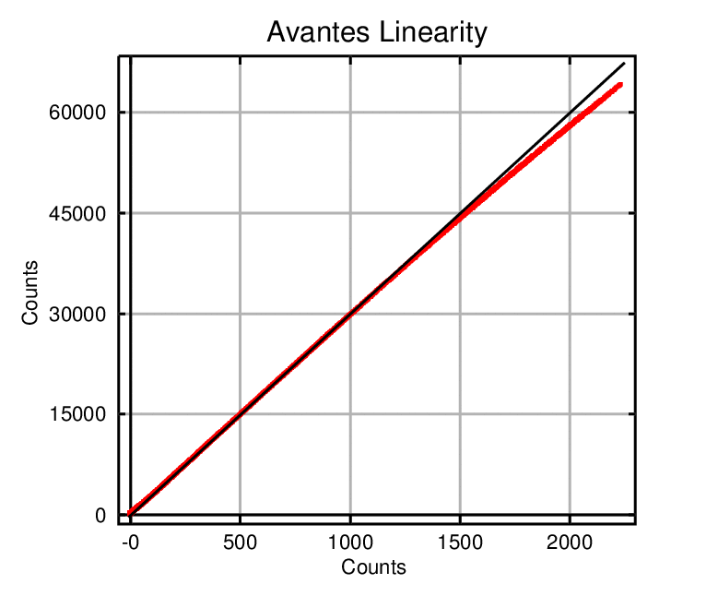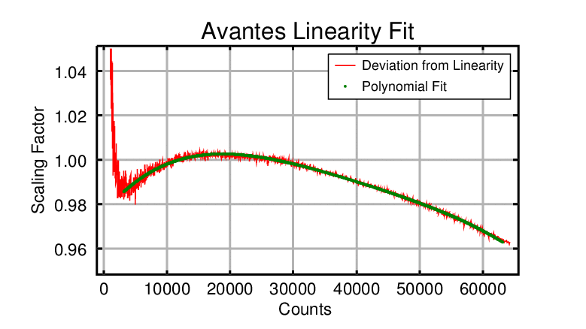

Figure 6: Example of results for a linearity calibration with an Avantes spectrometer system. Left: Correlation plot between measurements taken at two exposure times. Right: Relative deviation from perfect linearity and polynomial fit used for correction. At very low count rates results are unreliable because of noise.

Detector linearity can be determined in the lab by taking measurements of a broadband light source using a range of exposure times resulting in coverage of the full dynamic range. After dark signal correction, ratios of measurements taken at different exposure time should equal the ratio of the exposure times. It is important to use a shutter for these measurements as otherwise signal collected during readout will create artefacts. Deviations from this value indicate non-linearities. As light sources might be changing in intensity over time, care must be taken to keep the time between measurements short. In principle, a different linearity curve can be derived for each detector pixel. However, if the non-linearity is caused by the signal processing after the CCD readout (which is often the case) it is sufficient to determine a mean dependency for all pixels.

Alternatively to varying the exposure time, one can also change the distance between light source and instrument and thereby the signal strength. This method avoids possible complications from small differences in readout time depending on detector operation. However, the finite size of the light source and inhomogeneities in source brightness can be a problem.

Linearity measurements can also be performed using zenith-sky observations on a clear day at two or more exposure times. The large dynamic range in these spectra will allow coverage of a large part of the signal range in one single measurement if only the average linearity is to be characterised. Care must be taken to ensure that skylight is not changing between measurements for example from cirrus clouds.

## Detector pixel-to-pixel variability

Both CCD and Photo Diode Array (PDA) detectors have small variations in sensitivity from pixel to pixel. This will cancel when taking the ratio between two measurements taken with the same instrument, but only if the spectral calibration is completely stable. If this is not the case, pixel-to-pixel variability will introduce high frequency structures in the residuals.

Pixel-to-pixel variability can be characterised by taking a measurement with a broadband light source and applying a high pass filter on the result, for example by subtracting a version of the image / spectrum which has been smoothed over 5 pixels. Dividing all measurements pixel wise by this correction will cancel most of the detector variability. As pixel-to-pixel variability is a detector property which usually does not change over time, it is sufficient to characterize it once.

## Temperature dependence

Temperature changes of the instrument can influence the operation of a MAX-DOAS instrument in several ways. In particular, for instruments not having a temperature stabilisation, the spectral calibration of the instrument (conversion of pixel number to wavelength) will change with temperature as result of mechanical changes of the instrument. This necessitates application of shift and stretch spectral corrections in the DOAS analysis. In addition, defocusing due to mechanical changes can lead to changes in slit function which impact on the residual and the absolute accuracy of the absorption measurements. This can be at least partly compensated by fitting the slit function in the DOAS retrieval but is limited by parametrisation of the shape of the slit function and computation time.

Characterisation of the temperature dependence of the instrument can be done by systematically changing the instrument temperature by heaters or coolers over a temperature range covering all expected instrument temperatures while taking measurements of a spectral line lamp. Additional information on the overall instrument performance can be gained by performing this test during zenith-sky measurements on a clear day. It should be noted that instruments often show a temperature hysteresis so temperature changes should not be too rapid.

# Instrument Operation

Depending on instrument configuration and measurement target, operation protocols vary between instruments and applications. However, some general recommendations can be made on common practice.

## Operation parameters

### Which viewing directions

MAX-DOAS instruments have the ability to point at different parts of the sky for measurements. Observations in different directions can be used for different applications:

**Zenith-sky observations** are most useful for stratospheric studies, in particular if measurements are taken at twilight when light paths in the stratosphere are long. They are also usually employed as background (or Fraunhofer reference) measurements for the determination of tropospheric columns and profiles using off-axis measurements. If signals are sufficiently high, zenith-sky observations can also be used to extract tropospheric columns, albeit with lower sensitivity than achievable in off-axis mode.

**Direct sun observations** have the benefit of high signals and simple light path. They provide direct access to AOD and total columns if the absorption / extinction amount in the background spectrum can be determined with sufficient accuracy. The latter can be achieved e.g. using the Langley plot method, where measurements at constant absorber amounts but different solar zenith angle are plotted as function of air mass factor to determine the intercept with the y-axis. In combination with zenith-sky and off-axis observations, direct sun observations add additional constraints on the tropospheric column in profile retrievals.

**Off axis observations** at different elevation angles (usually between 0° and 15°) provide information on the vertical distribution and integrated amounts of absorbers and aerosol in the lower troposphere. They are usually combined with zenith-sky observations as background to remove the stratospheric component of the signal. Different azimuthal directions can be used to either explore horizontal gradients or – if horizontal variability can be assumed to be small – to extract information on the aerosol phase function.

**Target observations** using bright and dark surfaces at different distances can be used to determine mixing ratios averaged over relatively short distances from the instrument. This observation mode has similarity to active DOAS measurements but complications arise from scattering of sun-light and spectral structures introduced by surface properties of the targets (Frins et al., 2006, 2008).

### Which frequency of zenith-sky observations

The frequency of zenith-sky observations depends on the expected variability in trace gas concentrations, aerosol loading and air mass factor. As a rule of thumb, a zenith-sky measurement should be taken every 15 minutes (typically in-between successive MAX-DOAS elevation scans) and at larger frequency during twilight (for solar zenith angle larger than 85 degree).

### Which integration times per viewing direction

The optimal integration time per viewing direction depends on the target quantity and instrumental properties. For pollution measurements, short integration times of 10 – 60 seconds are beneficial in order to sample temporal variability. However, if the throughput of an instrument is small (e.g. due to low quantum efficiency of the detector) and/or absorption signals are small as in the case of BrO or IO, longer integration times are needed to reduce noise. For twilight observations, longer integration times are also needed to achieve signal to noise ratios of several thousands, as required to measure typical trace gas differential molecular absorptions of a few per mil or smaller.

When taking measurements from moving platforms such as airplanes or cars, even shorter integration times of 0.5 – 5 seconds are recommended in order to achieve good spatial resolution.

### Which strategy for exposure times

Different strategies can be applied to determine the optimum exposure time of individual scans:

1. A short test measurement can be taken prior to the real measurement to determine the exposure time (of an individual scan) which should aim at a saturation level of 50 to 75% of the nominal range of the detector. The advantage of this method is that it will usually result in good estimates, the disadvantage is that some time is lost.
2. Instead of a test measurement, the last measurement can be used to estimate the right value for the next measurement. This method is also reliable and does not need extra time but might be less accurate if the viewing direction is changed.
3. A very short constant exposure time can also be used and data then averaged to the desired integration time. This has the advantage of simplicity but does reduce signal to noise ratio as both photon shot noise and readout noise add up in this process. Also, the detector is usually not operated in its optimum linearity range which can introduce problems with non-linearity.

Regardless of the strategy chosen, atmospheric variability can lead to over-exposure and therefore saturation in the spectra which needs to be checked in the measurements in order to exclude such data from the analysis. Care must be taken to apply this check on individual scans and not on co-added or averaged spectra. If detector linearity does not extend the full range of the ADC, this needs to be taken into account when checking for over-exposure.

### Which data format

The GEOMS (Generic Earth Observations Metadata Standard) UVVIS.DOAS HDF format has been developed during the FP7 NORS project (see <http://nors.aeronomie.be/projectdir/PDF/NORS_D4.1_DFD.pdf>) for reporting level-2 UV-vis data in off-axis (trace gas + aerosols), zenith, and direct-sun viewing geometries. Corresponding templates and guidelines for file creation are described on the AVDC website (<http://avdc.gsfc.nasa.gov/index.php?site=1876901039>). The added value of the GEOMS HDF format resides in the possibility to include ancillary metadata which can be useful for the interpretation of comparisons between (MAX-)DOAS and satellite or model data, like averaging kernels, cloud conditions, location (latitude, longitude) of the effective air masses, etc. in addition to the trace gas or aerosol data. More general information about the GEOMS guidelines can be found at <http://avdc.gsfc.nasa.gov/PDF/GEOMS/geoms-1.0.pdf>.

## Automatic Characterisation Measurements

While some calibrations have to be performed in the lab, it is good practice to also perform some automated characterisation and calibration measurements on a regular basis to identify, characterise and document instrument changes for later use in data analysis.

### Dark signal

Dark signal measurements can be performed automatically preferably by using a shutter, or alternatively at night and by pointing the instrument to a dark surface. If measurements are performed without a shutter, signal height needs to be checked manually or automatically to reject measurements contaminated by light sources for example when street light is reflected from low clouds, fog, or snow covered ground or during full moon.

### Wavelength

Wavelength registration of the instrument is often monitored by taking regular measurements of a spectral line lamp having emission lines at known wavelengths (Hg, HgCd, HgNe, …). Alternatively, the wavelength calibration can also be performed via cross-correlation with a high resolution Fraunhofer atlas convolved with the instrument slit function. This step is often included in DOAS analysis packages such as the widely used QDOAS software (uv-vis.aeronomie.be/software/QDOAS/).

### Slit function

Temporal changes of the slit function can be monitored by taking regular measurements with a spectral line lamp or a laser. Such lamps can conveniently be integrated in the telescope for automatic measurements. For a good representation of the slit function, full illumination of the instrument needs to be ensured, for example by using a diffusor.

The slit function and its change over time can also be determined from the measurement of solar Fraunhofer lines by including a slit function fit in the DOAS retrieval (Caspar and Chance, 1997).

### Pointing accuracy

Pointing of the telescope can be monitored automatically using

1. Inclinometer readings if the MAX-DOAS scanner is equipped with such a device
2. Horizon scans or scans over a nearby target with sharp reflectivity contrast (see section 3.3.4) to monitor elevation pointing.
3. Elevation scans around the solar elevation but at an azimuth to the side of the sun to avoid direct sun light to check elevation pointing.
4. Azimuthal scans around the solar azimuth angle but at an elevation above or below the sun to avoid direct sun light to check azimuthal pointing.
5. For sun pointing instruments the sun can be scanned directly to determine the pointing of the instrument.

Measurements close to the sun will only work on clear days and if the sun is not too close to the horizon. Horizon scans also depend on weather and work best under clear sky conditions and in a direction not too close to the sun.

It should be noted that the results of the automated pointing measurements are best used for monitoring only and not for automatic compensation of misalignments as these could lead to problems in case of non-ideal conditions for the pointing measurements.

### FOV

As discussed in section 3.3, the horizon scans can also be used to characterize the FOV by evaluating the intensity distribution with elevation angle.

For sun pointing instruments, scans in elevation and azimuth across the sun can be used to characterize the FOV.

### Throughput

While for standard DOAS retrievals, absolute calibration of the measurements is not needed, radiometric calibration can provide additional information for aerosol and cloud retrievals and radiation studies. A relative radiometric calibration can be performed by using a white light source which is also integrated in some instruments. Full radiometric calibration necessitates use of calibrated lamps and usually is quite time consuming.

In order to monitor instrument throughput in a statistical sense, radiance or colour index values measured in the zenith-sky direction for a well-defined SZA range which is ideally available throughout the year can be averaged for each day and plotted as a function of time (e.g. Wang et al., 2015). While individual days can vary strongly due to meteorology, maximum values should remain unchanged over time.

## Automatic QA

As many MAX-DOAS operations are long-term measurements without on-site operator, automatic quality assurance measurements are important to identify instrument problems as early as possible. This can be done by a series of simple checks and figures:

### Intensity checks

Evaluation of measured intensity as a function of SZA and viewing direction can provide information on pointing malfunctions, telescope contamination with dirt, condensation water or ice or other obstruction (growing vegetation, new buildings). If the system has an integrated digital camera, these images can also be used to check on pointing and scene changes.

### Slit function

If slit functions can be determined on a regular basis from either spectral line lamp or laser measurements or fits in the DOAS retrieval, time series of FWHM of the slit function can be used to identify instrument changes and malfunctions.

### Wavelength stability

If regular spectral line lamp measurements are available, the peak position of strong lines can be determined from the data and analysed as a function of time. Any change beyond what is expected given the thermal sensitivity of the instrument indicates problems with the instrument or the thermal environment. Similar information can be obtained from the cross-correlation with a high-resolution Fraunhofer atlas.

Alternatively, the shift and stretch parameters from DOAS retrievals using a fixed background spectrum can be used to evaluate spectral stability of the instrument. The temporal evolution of the fitting residuals of such an analysis are also indicative of the overall stability of the instrument.

### Quick look DOAS retrievals

If the analysis is automated to a level that daily DOAS retrievals can be performed automatically, simple thresholds on intensities, fitting residuals and O4 columns can be used to identify measurements in need of visual inspection.

# References

Frins, E., Bobrowski, N., Platt, U., and Wagner, T., Tomographic MAX-DOAS observations of sun illuminated targets: a new technique providing well defined absorption paths in the boundary layer, Applied Optics, 45, 24, 6227-6240, 2006.

Frins, E., Platt, U., and Wagner, T., High spatial resolution measurements of NO2 applying Topographic Target Light scattering-Differential Optical Absorption Spectroscopy (ToTaL-DOAS), Atmos. Chem. Phys., 8, 6707-6717, 2008.

Carlson, D., Donohoue, D., Platt, U., and Simpson, W. R.: A low power automated MAX-DOAS instrument for the Arctic and other remote unmanned locations, Atmos. Meas. Tech., 3, 429-439, https://doi.org/10.5194/amt-3-429-2010, 2010.

Caspar, C. and K. Chance, GOME wavelength calibration using solar and atmospheric spectra, Proceedings of the 3rd ERS Symposium on Space at the Service of Our Environment, Volume 2, 609-614, ESA-SP-414-Vol-2, SEE 19990078327, 1997.

Cede, Alexander, Manual for Blick Software Suite, http://pandonia.net/media/documents/

Clémer, K., Van Roozendael, M., Fayt, C., Hendrick, F., Hermans, C., Pinardi, G., Spurr, R., Wang, P., and De Mazière, M.: Multiple wavelength retrieval of tropospheric aerosol optical properties from MAXDOAS measurements in Beijing, Atmos. Meas. Tech., 3, 863-878, https://doi.org/10.5194/amt-3-863-2010, 2010.

Coburn, S., Dix, B., Sinreich, R., and Volkamer, R., The CU ground MAX-DOAS instrument: characterization of RMS noise limitations and first measurements near Pensacola, FL of BrO, IO, and CHOCHO. Atmos. Meas. Tech., 4(11), 2421–2439, 2011.

Grainger, J. F. and J. Ring, Anomalous Fraunhofer line profiles, Nature 193, 762, 1962.

Wittrock, F., Oetjen, H., Richter, A., Fietkau, S., Medeke, T., Rozanov, A., and Burrows, J. P., MAX-DOAS measurements of atmospheric trace gases in Ny- Alesund - Radiative transfer studies and their application. Atmos. Chem. Phys., 4, 955–966, 2004.

Roscoe, H., D. Fish, and R. Jones, Interpolation errors in UV–visible spectroscopy for stratospheric sensing: implications for sensitivity, spectral resolution, and spectral range, Appl. Opt. 35, 427-432, 1996.

Sihler, H., Lübcke, P., Lang, R., Beirle, S., Graaf, M. d., Hörmann, C., et al., In-operation field-of-view retrieval (IFR) for satellite and ground-based DOAS-type instruments applying coincident high-resolution imager data. Atmospheric Measurement Techniques, 10(3), 881-903. doi:10.5194/amt-10-881-2017, 2017.

Wagner, T., Beirle, S., Dörner, S., Penning de Vries, M., Remmers, J., Rozanov, A., and Shaiganfar, R., A new method for the absolute radiance calibration for UV–vis measurements of scattered sunlight, Atmos. Meas. Tech., 8, 4265-4280, doi:10.5194/amt-8-4265-2015, 2015.

Wang, Y., Penning de Vries, M., Xie, P. H., Beirle, S., Dörner, S., Remmers, J., Li, A., and Wagner, T., Cloud and aerosol classification for 2.5 years of MAX-DOAS observations in Wuxi (China) and comparison to independent data sets, Atmos. Meas. Tech., 8, 5133-5156, https://doi.org/10.5194/amt-8-5133-2015, 2015.

Zong, Y., S. W. Brown, B. C. Johnson, K. R. Lykke, and Y. Ohno, Simple spectral stray light correction method for array spectroradiometers, Appl. Opt. 45, 1111-1119, 2006.